Hello Megan, It’s Ram from London south bank university. I would be very happy if you could provide me with a brief note on sample collection, sampling, Data acquisition, instrumental specifications, brief experimental setup for data acquisition, for writing the section on data acquisition. I will paraphrase it before use. Is it possible? Also blow there are classified very short answer questions for you, related to data acquisition process. Feel free to email me or send me a message on MS teams.
EPMA data questions
Data Accuracy
Measurement Accuracy:
Are the measurements accurate and reliable?
Were the instruments calibrated?
Is there documentation on error margins for the measurements?
All measurements for EPMA data should equal to 100 +- 1.5 %. If this is not the case and the value is outside of this, then the data must be disregarded for data analysis. These values are kept and published, but there should be an explanation of why the total is lower/higher, for example the analysis point could have been at a crack or gas bubble on the sample resulting in skewed results.
Yes. The instruments were calibrated using a range of standards. I have a table of the standards which I will attach in the email. These are run at the beginning and end of each day when the machine is used, and throughout the day to ensure accuracy.
There is no documentation for error margin. We use the standards to ensure accuracy, and together with the totals adding to 100 +- 1.5% we can assume reliability.
Measurement Precision:
Are the measurements sufficiently precise to capture subtle variations in composition?
For example, do minor or trace elements have detection limits that are adequate for distinguishing between samples?
Yes, the measurements can capture subtle variations in composition. This is why we run the calibrations. The detection limit for EPMA can be 1000 parts per million, therefore we can ensure accuracy.
Measurement Error:
Are uncertainties in measurements explicitly reported, especially for trace elements?
Validation with Standards
Are the results consistent with reference materials or known standards for clinopyroxene? Can link of standard geochemical reference can be obtained?
Benchmarking:
How do the compositions compare with reference datasets or average compositions of clinopyroxene from known geological settings?
Representativeness
Geological Representativeness
Does the dataset represent a variety of geological environments or is it biased toward specific settings (e.g., igneous vs. metamorphic clinopyroxenes)?
The data is from 12 basalt samples from a monogenetic volcanic field, with the samples from either lava flows or cinder cones. Samples area all igneous material. I have attached an image of where the samples were collected from for context.

Temporal Representativeness
If applicable, does the dataset cover a significant timespan, or is it limited to a specific time frame?
Ar Ar dating of the samples shows all are from the Quaternary Period. The 1st stage is ~1.2 Ma, the 2nd stage ~170 Ka, and the 3rd stage ~10 Ka. I will be doing more dating analysis to determine the ages of more samples to see if there are variations within the three periods in the coming months.
Spatial Representativeness:
Are samples distributed across multiple locations, or is the dataset localized to a few regions?
Samples are from multiple locations, see attached photo.
Temporal/Spatial Trends:
Are there differences in composition based on the time or place of sampling?
What is the range of values for major oxides (e.g., SiO₂, CaO, TiO₂)?
So far, there are clear difference between the 3 periods, but I have not identified difference within the 3 periods. I am currently writing my results and data interpretation so this could change. I have attached a table for the range of values.
Logical Anomalies:
Are there logical inconsistencies in the data (e.g., negative values for oxide percentages, physically impossible values)?
There have not been any inconsistencies identified as of yet.
Documentation and Metadata
Metadata Completeness:
Is there sufficient metadata (e.g., sample IDs, collection methods, geological context, units of amount) to interpret the data?
I have all of the above, including sample ID’s, a written description of the collection methods and some figures to represent this. Let me know if you need more information.
Versioning:
Is there clear documentation of data versions or any preprocessing steps applied to the data?
Noise and Signal
Signal-to-Noise Ratio:
Does the dataset have a high signal-to-noise ratio, or is there significant variability that might obscure meaningful trends?
Bias and Errors
Systematic Bias:
Is there evidence of systematic bias in the data collection (e.g., instrument drift, human error)?
None identified.
Sampling Bias: Were certain sample types preferentially collected, leading to potential biases in the dataset?
The 2nd period (T2) was difficult to collect sample in the field, therefore bias sample collection on where was accessible when visiting the volcano. 39 samples were collected in total, however only 4 samples have been analysed using these methods (EPMA and LA-ICP-MS). The chosen 4 samples from each period were chosen as spread across the area as possible.
Comparability
Inter-Dataset Comparability:
If merging datasets, are they comparable in terms of methodology, resolution, and scope?
Ethical and Practical Considerations Source Verification:
Are the sources of the data credible? Has the data been vetted for authenticity?
Legal Compliance:
Are there any data use restrictions, privacy concerns, or proprietary limitations?
No.
Elemental Distributions
Presence/Absence Analysis:
Are there components that are completely absent in some samples?
No.
Nature of Outliers:
Are outliers anomalies, or do they represent unique geochemical processes?
No.
Physical Constraints
Pressure-Temperature Conditions:
Can approximate formation conditions (pressure, temperature) be inferred?
Yes. We can use geothermobarometry to predict temperature, pressure, and depth base on the minerals present in the samples, and when the EPMA and LA-ICP-MS data shows. This is the final plans of the data interpretation.

Other LA -ICPMS data questions
. Data Integrity
- Are there redundant or conflicting columns, such as "Ca" and "Ca.1"? If so, are they properly documented?]
- Are all required columns present, and are their data types appropriate (e.g., float for concentrations, object for identifiers)?
- Are the concentrations normalized to appropriate reference values or standards?
- Is there metadata indicating how data below the detection limit (<DL) was treated (e.g., replaced with zero or half of DL)?
- Are derived columns, like "Ca.1," properly documented in terms of their calculation?
- Are there blank samples in the dataset, and are they properly flagged?

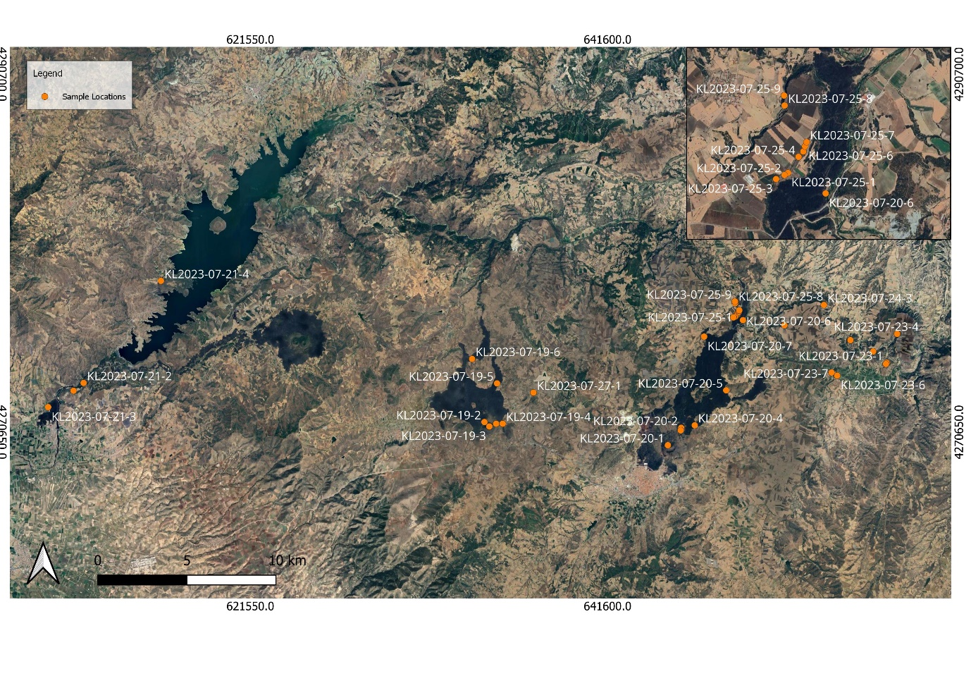
The data from the LA-ICP-MS is not normalised as it represents the true values. As the samples have been analysed in four different labs, some labs do not run elements in the analysis that are not significant. For example, Utrecht do not run Ni, F, V2O3, or Li2O whereas the other might. This is because each lab has a separate machine set up. This is not a problem as for EPMA, we are only interested in the major and most significant elements such as SiO2, Na2O, K2O, Mgo, MnO, FeO, Al2O3, TiO2, K2O, CaO.

Sample collection and sample names.

CPX |  | SiO2 | MgO | CaO | TiO2 | K2O | FeO | Cr2O3 | MnO | Na2O | Al2O3 | Mg#
Lisbon | 1st | 41.877-51.097 | 5.911-14.958 | 21.287-23.97 | 0.915-4.258 | 0-0.015 | 4.206-14.089 | 0.025-0.504 | 0.018-0.429 | 0.455-1.913 | 4.774-13.112 | 0.423-0.864
Utrecht |  | 43.3188-51.4758 | 6.7459-14.466 | 21.204-23.374 | 0.933-3.651 | 0.004-0.074 | 4.6724-13.957 | -0.004-0.37 | 0.071-0.415 | 0.5242-1.6301 | 3.1402-10.2565 | 0.464-0.839
Cambridge |  | 41.316-51.662 | 9.355-15.988 | 20.626-22.717 | 1.216-4.961 | 0.01-0.051 | 4.036-10.147 | 0-0.538 | 0.072-0.226 | 0.467-0.93 | 4.144-11.983 | 0.623-0.87
Sheffield |  | 41.83-47.98 | 6.05-14.85 | 21.23-24.02 | 1.468-4.35 | 0-0.118 | 4.91-14.34 | 0-0.072 | 0.031-0.105 | 0.454-1.88 | 6.69-11.28 | 0.432-0.843
Lisbon | 2nd | 39.168-51.024 | 6.142-14.696 | 21.878-24.427 | 0.462-4.284 | 0-0.024 | 3.856-13.681 | 0.016-0.53 | 0.03-0.587 | 0.432-1.687 | 2.991-14.837 | 0.443-0.869
Utrecht |  | 40.2022-51.8862 | 6.143-14.3122 | 21.264-22.8943 | 0.3368-3.9326 | 0.0029-0.0443 | 5.1411-13.416 | -0.015-0.3529 | 0.06658-0.51775 | 0.45307-1.73546 | 2.2114-13.463 | 0.448-0.824
Cambridge |  | 41.244-54.908 | 6.691-16.117 | 21.548-23.106 | 0.168-3.516 | 0.009-0.056 | 3.903-13.897 | 0-0.295 | 0.062-0.33 | 0.522-1.165 | 5.998-13.595 | 0.463-0.876
Sheffield |  | 40.58-45.98 | 8.84-12.7 | 22.21-23.27 | 1.86-4.55 | 0-0.019 | 6.63-11.74 | 0-0.053 | 0.05-0.108 | 0.571-1.169 | 6.92-11.46 | 0.581-0.769
Lisbon | 3rd | 42.31-51.973 | 7.376-14.591 | 20.26-24.455 | 0.057-4.011 | 0-0.03 | 4.833-16.404 | 0.046-0.627 | 0.017-0.473 | 0.226-1.94 | 0.536-11.66 | 0.443-0.841
Utrecht |  | 43.5954-50.4771 | 10.4096-15.0013 | 21.3384-22.7591 | 1.0218-4.0659 | 0.0033-0.05147 | 4.5943-8.76151 | -0.007-0.32758 | 0.0836-0.28259 | 0.52509-1.93773 | 4.64129-9.9252 | 0.682-0.846
Cambridge |  | 43.935-50.798 | 9.037-15.162 | 20.759-22.497 | 1.028-4.086 | 0.011-0.097 | 4.584-10.521 | 0-0.846 | 0.087-0.316 | 0.445-1.696 | 4.877-11.214 | 0.6-0.846
Sheffield |  |  | 10.4-15.03 | 21.4-22.81 | 1.65-3.81 | 0-0.161 | 4.62-7.53 | 0-0.687 | 0.056-0.174 | 0.604-1.206 | 6.18-11.19 | 0.716-0.854

These are the min and max values for my data. The ‘typical’ values for a basalt can be found online.

EPMA Lisbon:
EPMA analysis was performed at the Faculty of Sciences of the University of Lisbon, Portugal using a JEOL-8200 EPMA, equipped with an EDS spectrometer, four WDS spectrometers, and eight crystals of six types including TAP, LDES, LIF, LIH, PETH, and PETJ (Appendix ?). Operating conditions used were 15 kV and 25 nA, with a spot size of 5 µm for all mineral phases.
The counting time was 20 seconds on-peak and 5 seconds off-peak for all elements. Calibration was done using the following standards: Benitoite, Apatite, Tugtupite, Kaersuite, Johannsenite. Jadeite, Chromium oxide, Rhodonite, sanidine, nickel silicate, diopside, rutile, vanadium, willemite, almandine garnet, spodumene, and olivine (Appendix ?).
EPMA Cambridge:
EPMA analysis was performed at the Department of Earth Sciences, at the University of Cambridge, using a JEOL JXA-iHP200F equipped with 5 wavelength dispersive spectrometers (WDS), an EDS detector, using Probe for EPMA software.
Operating conditions used were 15 kV for all mineral phases, with a beam current of 10 nA for Amph, 20 nA for CPX, and 40 nA for Ol. The spot size was 5 µm for CPX, Amph, and Pl, and 1 µm for Ol.
Elements were acquired using analysing crystals TAP, TAPL, PETL, PETH, and LIFL (Appendix ?). The following primary standards were used for calibration: diopside, periclase, rutile, KSpar, fayalire, Mn_metal, jadeite, corundum, Cr_metal, Mn_metal, StJohnOl, and NiO. Accuracy was monitored with the following secondary standards from the Smithsonian Natural Museum for Natural History: Cr_augite 164905 and Kakanui Augite_122142 for CPX, san carlos olivine 111312-44 for Ol, and kaersutite_kakanui and Plagiocalse (lab)_115900 for Amph. The on-peak and off-peak counting times differs for each element and each mineral phase (Appendix ?).
The elemental distribution was analysed using elemental mapping. The mapping was performed with an accelerating voltage of 15 kV to optimise both spatial resolution and elemental excitation for the elements of interest, which included Ca, Cr, Na, Ti, Mg, Si, Fe, Mn and Al. a resolution of x95 was selected ensuring high spatial resolution.
EPMA Sheffield:
EPMA analysis was acquired at the Sorby Centre at the University of Sheffield, using a JEOL-JXA-8530F Plus Hyper Probe. Operating conditions were 15 kV and 15 nA and a spot size of 2 µm for all mineral phases.
The counting time was 30 seconds on-peak and 30 seconds off-peak for all elements. The following primary standards were used for calibration: diopside, Ti, rutile, alumnium oxide, Willemite, chronium oxide, orthoclase, jadeite, Fe/olivine, V, Mn, Albite, and Ni (Appendix ?).
The elemental distribution was analysed using elemental mapping with the same conditions at Cambridge.
3.2.6 LA-ICP-MS:
Trace element analyses of mineral phases (CPX, Amph, Ol and Pl) were performed at the Department of Earth Sciences “A. Desio” of the University of Milan using an Analyte excite 193 nm ArF excimer laser coupled with a Thermo Fisher Scientific iCAP-RQ mass spectrometer. The operating conditions were the following: 6 J/cm² fluence, 40 µm (CPX, Amph and Ol) and 65 µm (Pl) spot size and 10 Hz repetition rate. The acquisition time was 60 seconds on the sample and 40 seconds on the background. Data reduction was carried out with the software package GLITTER (Griffin, 2008) using SiO₂ wt% (Amph, Ol and Pl) and CaO wt% (CPX) concentrations from microprobe analyses as internal standard. The international reference material BCR-2G (Jochum et al., 2005) was used as calibration standard and reference glasses (NIST612, Pearce et al., 1997; ARM-3, Wu et al., 2019; GSD-2G and ATHO-G, Jochum et al., 2005) were used to monitor accuracy. The reproducibility is less than 20% for most elements. Data are reported in the Table xy.

